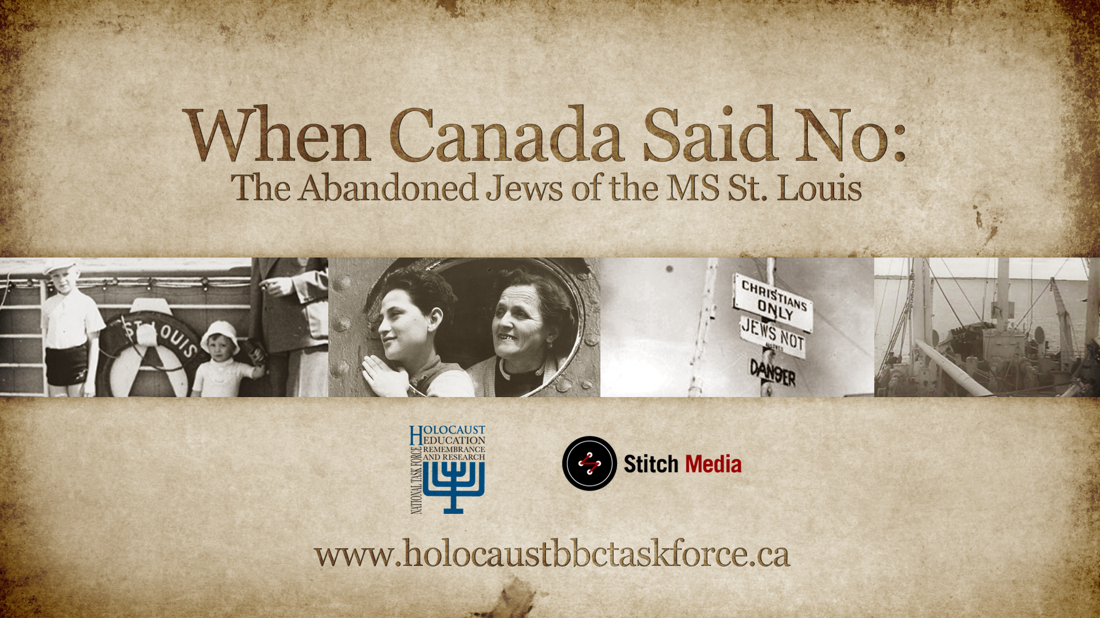

Lesson Guide

John Myers
OISE/University of Toronto

Prepared for the National Task Force on Holocaust Education, Remembrance and Research

While this 17-minute video can be shown in its entirety in one shot followed by a whole class discussion and take up of answers from a question sheet that students complete individually, students may deepen their understanding through a combination of strategies such as those described here.

Cause and Effect Organizer

The first strategy uses a graphic organizer to help students focus and link their thinking to important content and concepts when they delve deeply into an issue leading to improved achievement (Marzano, Pickering, and Pollock, 2001).

This organizer is based on Stephen Hawking’s cone representation of the relationship between time and space (1988). It can be used to examine cause-event-effect relationships (Hundey, 2007). The example comes from Oshawa’s Central Collegiate history teacher Flora Fung (2008).

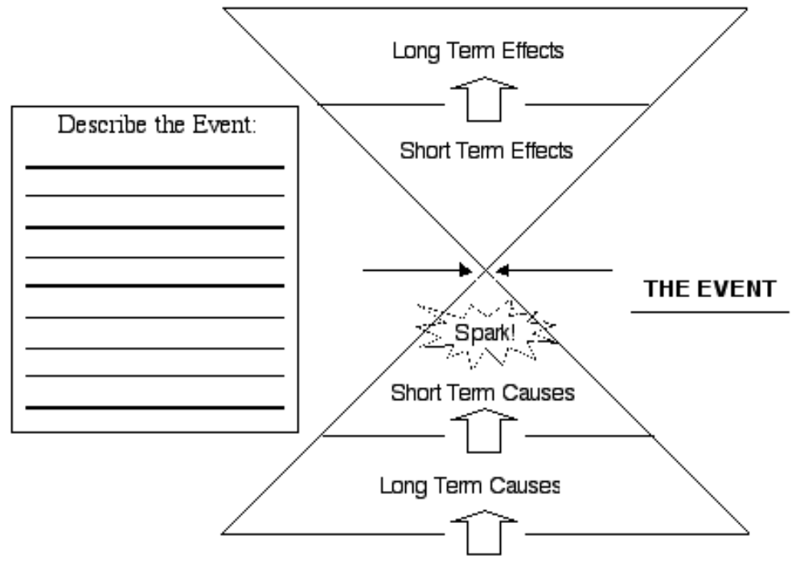

Note the idea of a “spark” or trigger for the event in question. As students watch the DVD, can they identify a spark that convinced Jews in Germany to leave and take the voyage in the Ms St. Louis?

While much of the chart can be completed with just the film using the film with the student book Welcome to Canada?* provides a deeper level of looking at the causes and effects of the events in the DVD.

If you decide to stop the DVD on occasion here is a pairs strategy to us:.

Pairs View (Morton, 1996)

When showing a video or delivering a lengthy presentation, teachers need to give students an opportunity to construct meaning: a necessary step in learning facts and concepts. Constructing meaning consists of linking old knowledge to new knowledge, making predictions, verifying them and filling in a lot of unstated information. For example, your prior knowledge about sharks will enable you to make predictions about what you will see in a documentary film about them. Such predictions are verified or refuted as you watch the film. Finally, what you know about sharks helps you fill in pieces of unusual information; e.g., that Sharks have no backbone- it’s cartilage. Here is one technique to help students do this.

- Pair students A and B.

- When showing a lengthy film, stop every ten minutes or so (five minutes for younger children)

- When the film is stopped for the first time, tell the pairs that A (or B) will be the summarizer. Declaring the roles at the last minute keeps both members of the pair accountable. If you decide that A is the summarizer, then A
  - summarizes for B the information and ideas presented so far
  - tells B what he/she finds most interesting about what was presented
  - identify anything that was confusing and try to clarify, with B’s help

- After three minutes, the film is turned on again

- After a suitable period, the film is again stopped and B takes the lead. Or you can repeat with A.

Alternatively, the teacher can provide a worksheet or a series of prompts to spur discussion and to enable students to record appropriate points. Prompts might ask students to summarize, predict, elaborate, describe, determine the main idea, compare, formulate questions, and identify aspects that interested or confused them about the presentation to date.

Two places to pause the DVD are:

- When the narration refers to “an humanitarian appeal” while the St. Louis is waiting in Cuba at the five minute mark. This section ends with the phrase “Canada wanted no part of that.” In the pause students can discuss why Canada might not be interested in helping
- at the end of the Sigler family account just after the nine minute mark (9’18”) Students can summarize and review attitudes in Canada towards Jewish people during the 1930s

Here are some additional strategies for use:

Wall of Fame or Wall of Shame?

Students design a Wall of Fame and a Wall of Shame and determine who deserves to be on either wall and why. Candidates include:

- the Cuban President
- Mackenzie King
- F.C. Blair
- Gustav Schroeder
- the Globe and Mail newspaper

Further Explorations
A recent edited work on Canada’s responses to events in Europe during the Nazi period (Klein, 2012) has a chapter looking at the how Canadian media responded to the voyage (Grzyb, 2012) and a chapter on the wartime voyages of the Serpa Pinto that proved to be an exception to the standard Canadian immigration policy of the time (Margolis, 2012).

An ironic admission of Jews to Canada during this period is on display at the Vancouver Holocaust education Centre until June of 2013. Lesson ideas accompanying artifacts and primary sources can be found at http://www.museevirtuel-virtualmuseum.ca/edu/ViewLoitCollection.do?method=preview&lang=EN&id=25457
and
http://www.enemyaliens.ca/

Parallel Events in Canadian History?

Students can examine other events involving refugees coming to Canada through Welcome to Canada? The Teacher’s Resource Guide offers many ways to use the story of the MS St. Louis to deepen understandings of the issues raised in the DVD. Ronald Atkey plays an interesting role and students can investigate his career as Employment and Immigration Minister to understand why he plays an important role in the DVD.

References
Abella, I. and Troper, H. (2000). None is Too Many: Canada and the Jews of Europe 1933-1948. Toronto: Key Porter Books.

Donovan, M.S. and Bransford, J.D. (2005). Introduction. M.S. Donovan and J.D. Bransford, Editors. How Students Learn: History, Mathematics, and Science in the Classroom. Committee on How People Learn, Washington, DC: The National Academies. 1-27.

Fung, F. (2008). Personal communication.

Grzyb, A. (2012). From Krystallnacht to the MS St. Louis tragedy: Canadian press coverage of Nazi persecution of the Jews and the Jewish refugee crisis, September 1938 to August 1939. Klein, L.R. (ed.) (2012). Nazi Germany, Canadian Responses. Montréal: McGill University Press. 78-113.

Hawking, S.W. (1988). A Brief history of Time: From the Big Bang to Black Holes. New York: Bantam Books.

Hundey, I. (2007). 9 Habits for Success in Teaching History. Toronto: Emond Montgomery.

Klein, L.R. (ed.) (2012). Nazi Germany, Canadian Responses. Montréal: McGill University Press.

Margolis, R. (2012). A review of the Yiddish media: Responses of the Jewish immigrant community in Canada. Klein, L.R. (ed.) (2012). Nazi Germany, Canadian Responses. Montréal: McGill University Press.114-143.

Marzano,R.J., Pickering. D.J., and Pollock, J.E. (2001). Classroom Instruction that Works: Research-Based Strategies for Increasing Student Achievement, Alexandria, VA: Association for Supervision and Curriculum Development.

Morton, T. (1996). Co-operative Learning & Social Studies: Towards Excellence and Equity. Kagan Co-operative Learning Publishers, 1996.

